THIS IS THE CLOSET MODEL, COST w/ EQUVILATE FEATURES TO THE ONE THAT WAS STOLEN

500W Solar Street Light, 480 LED Dusk to Dawn Outdoor Lighting for Security, Solar Flood Light Motion Sensor Outdoor Light for Parking Lot, Yard, Garden, Patio, Driveway.
Visit the Gebosun Store

$99.99 with 26 percent savings -26% $99.99.
Typical price: $135.99 Typical price: $135.99 FREE Returns

Brand | Gebosun
Color | Black
Material | Aluminum, Acrylonitrile Butadiene Styrene
Style | Modern
Light fixture form | Can be place on a pole

About this item
- 【500W High Brightness】 500W solar street light outputs high brightness through 480 LED light chips, 85°-145° wide beam angle covers more area on driveways and other areas to escort the safety of you and your family. The first choice for night security lighting.
- 【High-efficient Solar Panel】 Patented Pro Double MPPT Core Technology, Larger solar panel, is a technique used commonly with wind turbines and photovoltaic (PV) solar systems to maximize power extraction under all conditions. fast charging, energy conversion efficiency improved 35%-45% from other solar panels and store electrical energy in built-in 48000mAh battery, keep lighting even 3-5 rainy days.
- 【IP65 Waterproof and Sturdy Battery】IP65 waterproof grade rating makes this solar street light work well even in bad weather all year round. Equipped with cold-resistant and heat-resistant batteries, provides good lighting performance even in hot summers and cold winters.
- 【2 Way Easy Installation for Variety Usage】 Comes with 2 kinds of mounting screws, can be mounted to wall or on the pole without wire easily, gives you plenty of options as to where you position your lights, such as use as a solar streetlight, solar post light, solar commercial & area light, solar flood security light, solar barn light and solar parking lot light.
- 【Dusk to Dawn Outdoor Lighting & Motion Sensor】 Auto on at dusk, auto off at dawn, you don't have to spend extra time every day to switch this solar street lights on and off, and motion sensor only work at night : 30% brightness lighting when no motion detected; 100% brightness lighting when motion detected; 20S recovery 30% brightness lighting after the person leaves the motion sensor distance is 39.38-47.25 inches.

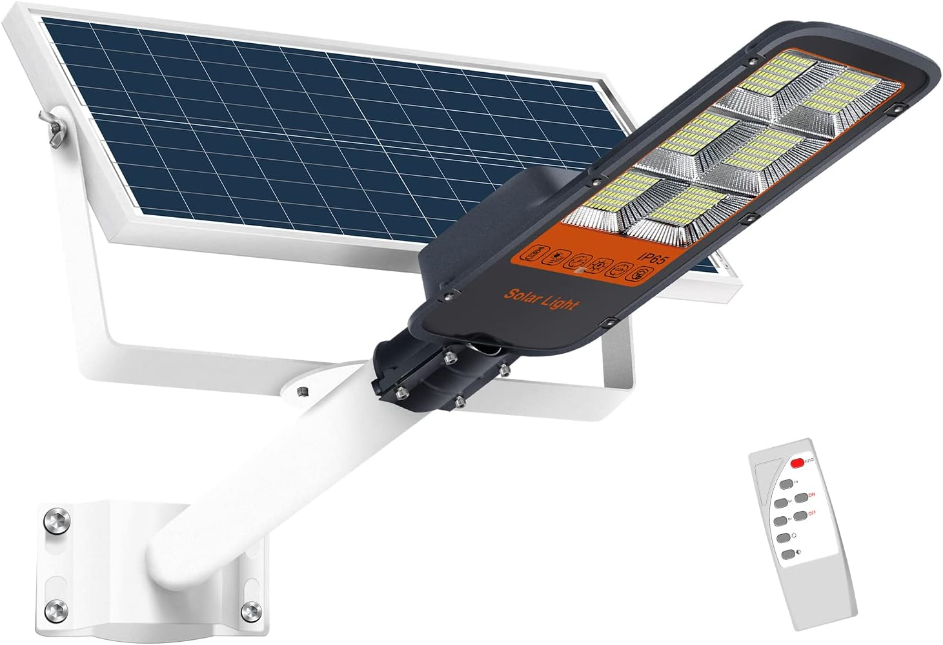
$99.99
FREE Returns
FREE delivery Saturday, November 11. Order within 3 hrs 1 min

Delivering to Astoria 97103 - Update location

Only 17 left in stock - order soon.

THIS WAS THE MODEL OF THE LIGHT THAT WAS STOLEN

TENKOO 400W Solar Street Flood Light Outdoor Motion Sensor Dusk to Dawn Solar Fixture with Remote Control IP66 Waterproof Led Pole Lights for Parking Lot Stadium Garden Pathway(Daylight White)

Currently unavailable.
We don't know when or if this item will be back in stock.
Brand | TENKOO
Color | Black
Material | Glass
Style | Modern
Light fixture form | Wall

About this item
- 【0 Electricity Bill 】---This 400W led street light can provide 6500k daylight white as it equipped with 792pcs LED beads 20000 Lumens high quality LED beads and 3.2v-42Ah battery(life up to 50,000 hours). IP66 waterproof grade make it works well even in bad weather all year round. Die-cast alum Vinum frame and high efficiency solar panels makes it good heat dissipation ,durable and lighting performance.
- 【Light Sensor & Motion Sensor】--- Dusk to Dawn, led outdoor lamp continuous lighting for 16 hours (fully charged). Led streetlight will automatically switch to 100% brightness when it detects an object moving. Solar floodlights outdoor can keep your house secure when strangers’ approaches. Maximum power saving.
- 【Remote Control】--- Providing convenience use in long distance for multi modes. Motion sensor mode, constant light mode, timing mode. The remote control distance approx 16ft.
- 【Easy Installation and Cordless 】---This outdoor solar powered lights comes with assembly accessories set , Mount on the wall, pole, tree, balcony, anywhere outdoor. No wiring required, no maintenance. Ideal for street and roads, courtyard, parks, squares, private gardens, courtyard, etc
- 【3 Year After-sales Service】---We promise 3-years product warranty, Lifetime Free After-service and Technical Support from manufacturer seller, worry-free with more than 50,000 hours long lifespan solar flood lights. Please Feel free to contact us if any issue arises.

- IMAGES
