Harbor Freight Tools

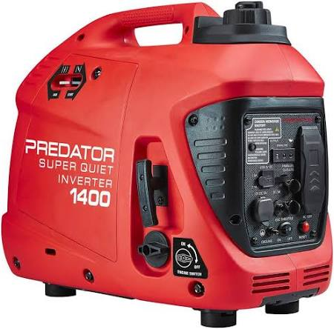
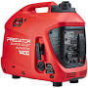
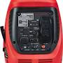
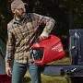

Predator 1400 Watt SUPER QUIET Inverter Generator with CO SECURE Technology
⁦4.6⁩/5 (⁦360⁩ user reviews)
Typically ⁦$470⁩

Harbor Freight Tools
⁦Predator 1400 Watt SUPER QUIET Inverter Generator with CO SECURE Technology⁩
$6.99 delivery Nov 10 – Dec 1
90-day returns
$469.99

Base price
$469.99
Delivery
+ $6.99
Estimated tax
+ $0.00
Estimated total
$476.98

⁦Visit site⁩

⁦View details⁩

About this product
⁦The PREDATOR 1400 Watt Max Starting, 1100 Watt Running SUPER QUIET Inverter Generator uses built-in inverter technology to produce clean power ideal for sensitive electronics such as TV's and laptops. The ultralightweight design is one of the lightest inverter generators available in the market, weighing only 33 lbs., making it ideal for camping, boating, and RV use. And at only 60 dB(a), this inverter generator runs as quiet as a conversation.⁩
...More
Brand
Predator Generators
Type
Portable
With Inverter
Yes

