APPLICANT’S SUPPLEMENTAL APPLICATION NARRATIVE (REVISED)
DATE: December 12, 2023

APPLICATION: City Casefile #0701-21-1 DR

APPLICANT: Ken and Lynn Ulbricht
Botts Marsh, LLC
P.O. Box 1161
Seaside, OR 97138

COUNSEL: Jennie Bricker
Land Shore Water Legal Services, LLC
818 SW Third Avenue, PMB 1517
Portland, OR 97204

SITE LOCATION: Tax Lots 400, 4600, 4700, 4800, Map 2N10W2BC

ZONING: Water-Related Commercial, Water-Related Industrial

PROPOSAL: Design Review to construct a building that includes processing, storage, and retail sales of fish and shellfish.

BACKGROUND

Site: The property is currently vacant. It is adjacent to Nehalem Bay. North of the site is a wetlands complex, Botts Marsh, that is now permanently protected from development. The parcel to the south, also zoned WRC, is vacant. Nehalem River borders the site to the west. At the site’s eastern border are a railroad right-of-way and a leasehold with separate commercial development. Highway 101 lies east of the railroad and leased parcel.

Land Use History: Before it burned down in the 1960s, a shake and shingle mill operated on the property and extended out into Nehalem Bay on pilings. In the 1970s, the property was enlarged and elevated through deposition of dredge spoils. The previous owners held title to the Botts Marsh wetland area as well as the current property that is the subject of this application. They proposed a development that would have included 200 condominiums (later reduced to 95) and commercial uses on the upland parcel; they proposed to drain the Botts Marsh wetlands to construct a private marina. The previous owners pursued their development of the Botts Marsh wetlands under a Goal 16 (Estuarine Resources) exception in the Tillamook County comprehensive plan. The Oregon Supreme Court upheld the exception in 1987.

The applicant purchased the wetlands together with the project site. Ken Ulbricht was formerly president of the North Coast Land Conservancy. He acquired the property with the goal of permanently protecting the wetlands from development. He conveyed title to the wetlands to the Conservancy on March 12, 2019; NCLC in turn transferred title to the Lower Nehalem Community Trust, which “will maintain the property for the benefit of the ecological values of the estuarine marsh under a conservation easement held by the Oregon Watershed Enhancement Board” (see Botts Marsh Management Plan (2019) at 3). In planning to develop the upland area south of the wetlands, the applicant anticipates continued cooperation with LNCT to ensure that development will not threaten the ecology of the wetlands (see Botts Marsh Management Plan).

Procedural Background: The applicant first submitted conditional use applications in August 2019 to construct a commercial building and a boutique, 28-room hotel. Following appeals from the Planning Commission, the Wheeler City Council conducted de novo review of the applications on April 21, 2020, and voted to approve. The Oregon Coast Alliance and three individual project opponents appealed the decisions to the Oregon Land Use Board of Appeals. LUBA remanded the decisions for more detailed findings. On remand, the City Council voted to deny. The City issued final decisions on July 6, 2021. The applicant appealed the decisions to LUBA. LUBA remanded the decisions because of procedural errors. On May 24, 2022, the City Council again voted to deny the conditional use applications.

After the first conditional use denial, the applicant changed the development to include uses permitted outright in the WRC and IND Zones, submitting a design review application for approval of a commercial building for fish and shellfish sales on the WRC parcel, and a connected fish processing plant on the IND parcel. The DR application was deemed complete on August 27, 2021. The City’s Staff Report recommended approval; however, the Planning Commission denied the application after a tie vote with one abstention. The applicant appealed to City Council, which conducted a de novo hearing on November 16, 2021, and voted to deny. The Council issued its final decision on December 15, 2021; the applicant appealed to LUBA; and LUBA remanded the decision. On August 4, 2022, the applicant provided supplemental materials to address the City’s reasons for denial; however, the City did not reopen the record on remand and did not consider the materials. Rather, the Council again denied the application on August 16, 2022. On appeal, LUBA remanded with instructions to reopen the record. The City appealed LUBA’s decision to the Oregon Court of Appeals, which agreed that the record should have been reopened. The application is now before the City Council for the third time.

APPROVAL CRITERIA

In order to be approved, the design review application must satisfy the standards listed in Section 11.050 (Design Review) of the Wheeler Zoning Ordinance, as well as Section 11.111 (Shoreland Development), Article 2 (WRC Zone), and Article 3 (IND Zone).

The sections that follow address the deficiencies the City identified in its decisions on December 15, 2021, and August 16, 2022 (together, the “Decision”); incorporate relevant portions of the opinions on review by LUBA and the Oregon Court of Appeals; and reflect the comments, requirements, and suggestions of City representatives in a meeting with the applicant’s attorney on November 1, 2023, as well as during the City Council meeting on December 6, 2023.

WZO Section 11.050.2 requires consistency with Comprehensive Plan policies and ordinance provisions.

The City’s Decision found the application sufficient under this section. Specifically, the Decision found the application consistent with Goal 9, Policy 3; and Goal 16, policies 2.A, 2.C.2.b, 4.J.8, 4.J.9, 4.J.11, and 4.J.12.

WZO Section 11.050.3 establishes application requirements.

The City’s Decision found the application sufficient under this section.

WZO Section 11.050.4.a establishes guidelines for site design.

Subsection (1) addresses natural and topographic features.

The City’s Decision found that the application met this guideline.

Subsection (2) addresses trees and vegetation.

The City’s Decision found that the application met this guideline.

Subsection (3) addresses landscaping and replanting.

The City’s Decision found that the application met this guideline and added that an NPDES 1200-C permit would be required from the Oregon Department of Environmental Quality.

Supplemental Response: The applicant provided the City with a copy of the NPDES 1200-C permit from DEQ on October 30, 2023.

Subsection (4) addresses exterior lighting.

The City’s Decision found that the application met this guideline and also satisfied lighting requirements in Section 2.040.3 and Section 3.040.3.

Subsection (5) addresses screening and enclosures.

The City’s Decision found that the application met this guideline and also satisfied screening requirements in Section 2.040.2 and Section 3.040.2.

Subsection (6) provides as follows: “Primary building entrances shall open directly to the outside and shall have walkways connecting them to the street sidewalk. Create storefronts and entries that are visible and easily accessible from the street. Either orient the primary entrance to the building along a street facing property line or create an ADA accessible courtyard/plaza incorporating pedestrian amenities including street trees, outdoor seating and decorative pavers. Ensure a direct pedestrian connection between the street and buildings on the site, and between buildings and other activities within the site. In addition, provide for connections between adjacent sites, where feasible.”

The City’s Decision found that the application did not meet this guideline. The reasons for noncompliance are listed below, together with the applicant’s responses, application revisions, and supplemental application narrative.

- The two sides of the parking lot lack a “direct pedestrian connection” because the loading area divides the parking spaces and could create safety problems for pedestrians. The loading and truck maneuvering area must be relocated outside of the visitor parking lot.

Supplemental Response: The applicant has revised the site plans to provide separate driveways for passenger vehicles and for trucks. The loading area has been relocated to the north elevation, with a dedicated paved area for truck traffic and loading/unloading. The parking area for passenger vehicles remains at the east entrance, with visual and pedestrian connections to the courtyard, but the parking area has been condensed to create a physical separation between pedestrians and truck maneuvering. The revised plans are included with this supplement.

- The entry ways on the west and north sides of the building do not have access via sidewalks.

Supplemental Response: The applicant has revised the site plans to provide sidewalks connecting the parking area to all primary and secondary entrances to the building. The revised plans are included.

- The Decision stated that a courtyard is needed where a building’s primary entrance does not face the street. Although the applicant identified a “courtyard” in the application narrative, it was not identified on the site plans. A “courtyard/plaza” must be visible from the street and designed to draw visitors to the primary entrance. It must include trees, outdoor seating, and decorative paving and must provide enough open area to allow for tree growth.

Supplemental Response: The applicant has revised the site plans to identify the “courtyard/plaza” at the primary commercial entrance. In addition, the revised plans identify “pedestrian amenities” in the courtyard/plaza area, including benches, trees, and decorative pavers. The courtyard encompasses open areas as well as a small covered area. It is visible from Marine Drive and obvious and inviting to visitors via the parking area. As requested during the December 6, 2023, City Council meeting, the applicant has extended the decorative paved area, placed a low wall and shrubs on the south and west boundaries to create more of a “courtyard” appearance, and has restricted the trees to no more than 24 feet in height. The revised plans are included.

Subsection (7) addresses “community amenities.”

The City’s Decision found that the application met this guideline.

Subsection (8) addresses landscaping requirements.

The City’s Decision found that the application met this guideline, and that WZO Section 3.040.4, a buffering requirement in the IND Zone, was not applicable.

Subsection (9) addresses parking.

The City’s Decision found that the application met this guideline and also satisfied parking requirements in WZO Section 11.090.

Subsection (10) requires an ADA accessible “pedestrian access system.”

The City’s Decision found that the application met this guideline.

WZO Section 11.050.4.b establishes guidelines for building design.

Subsection (1) provides as follows: “The height and scale of the buildings should be compatible with the site and adjoining buildings. Use of materials should promote harmony with the surrounding structures and site. The materials shall be chosen and constructed to be compatible with the natural elements and applicable city ordinances.”

The City’s Decision found that the application did not meet this guideline. The reasons for noncompliance are listed below, together with the applicant’s responses, application revisions, and supplemental application narrative.

- The application did not demonstrate “how the height and scale of the proposed buildings will be compatible with the site or adjoining buildings.”

Supplemental Response: The project design is compatible with the site’s layout and topography. As shown in the site plans, the footprint of the building and landscaping follow the curved Marine Drive alignment to the east and the sinuosities of the Nehalem Bay shoreline to the west. The project design is compatible with the site in terms of height and scale. The building will not exceed the Zones’ height limitation of 24 feet, and the building consolidates a commercial and an industrial use, thereby reducing the structure’s footprint and impact on the natural shoreline. As shown on the site plans submitted with the original application, reproduced below, the building occupies only a small portion of the site’s total acreage:
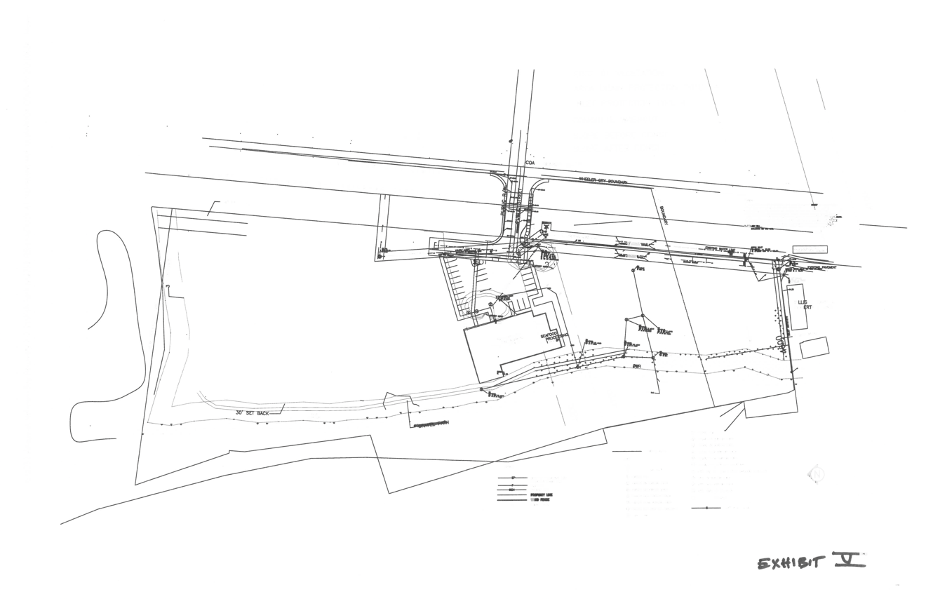
To the north and south of the building and parking area (north is toward the left of the above image), the site remains open space. North of the property boundary lies the Botts Marsh protected wetlands. The parcel south of the site is undeveloped but owned by the applicant. Further south, beyond the boundary of the undeveloped parcel, is a half-acre parcel that, to the best of our knowledge, is owned by Rick Dart. The Dart parcel is developed with a residence, a storage building, and two large commercial buildings:

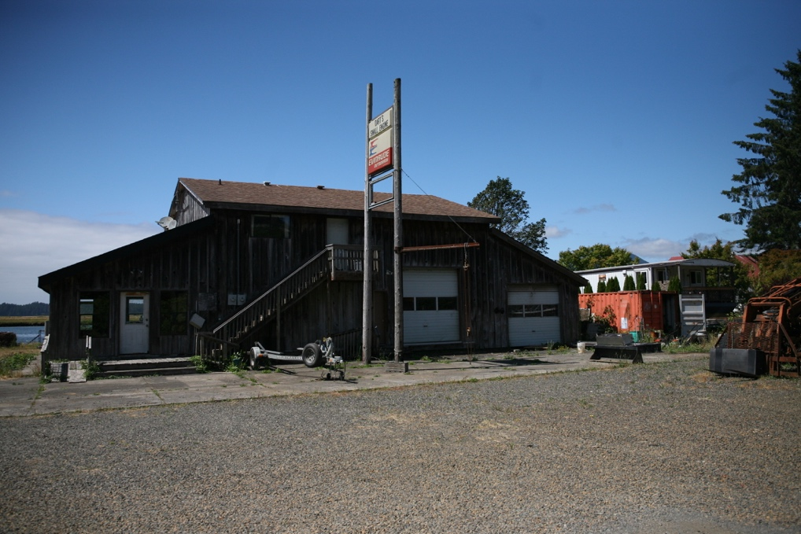
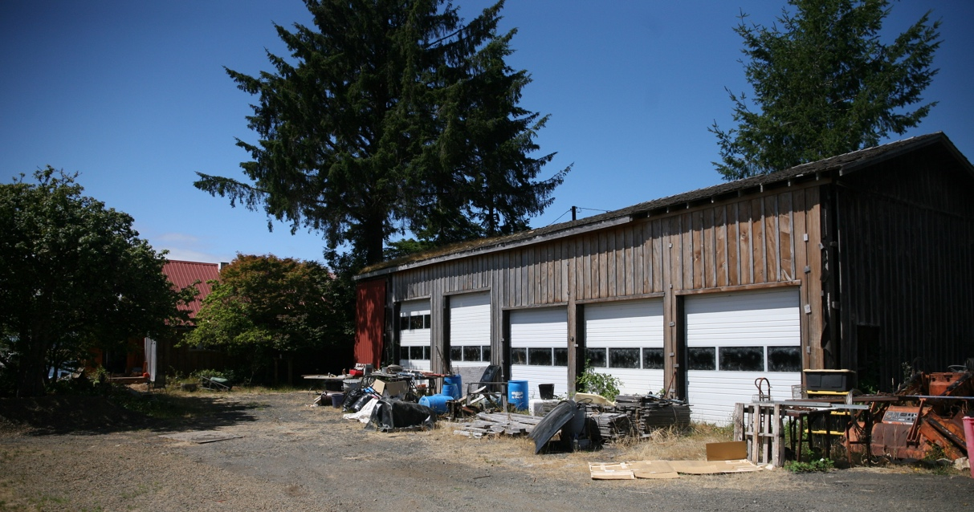

The two photographs above show the large commercial buildings on the Dart property. They are similar to, and compatible with, the project design. The Dart buildings and the project design share similar features, such as board-and-batten wood siding, pitched roofs, large bay doors, smaller “man doors,” and upper story windows. A residence on the Dart property, which is partially visible at the far left of the photograph above, has metal roofing, like the proposed project.

The subject property is bounded to the west by the Nehalem River. The Tillamook County railroad property lies between the property’s east boundary and Highway 101.

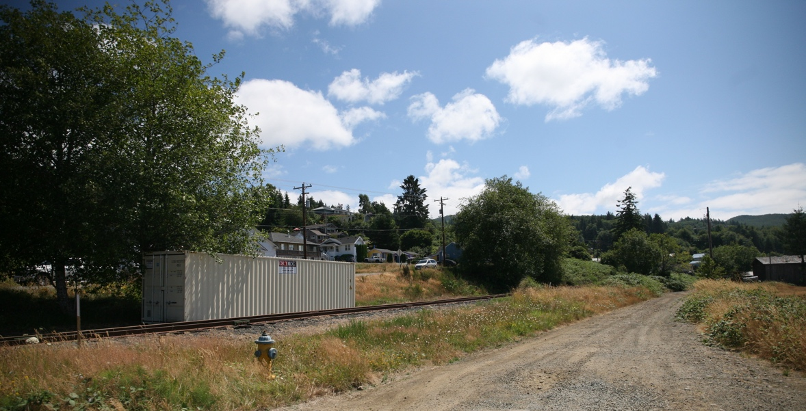

The Tillamook Rail Riders operates out of the metal container pictured above. This business, which rents “rail riders,” or lightweight, pedal-powered rail bikes for use on the rail line, is located on the railroad property between the subject property and Highway 101. The subject property boundary lies at the gravel road and extends past the right edge of the photograph.

Another commercial structure, the Handy Creek Bakery, is located across Nehalem Boulevard from the subject property:

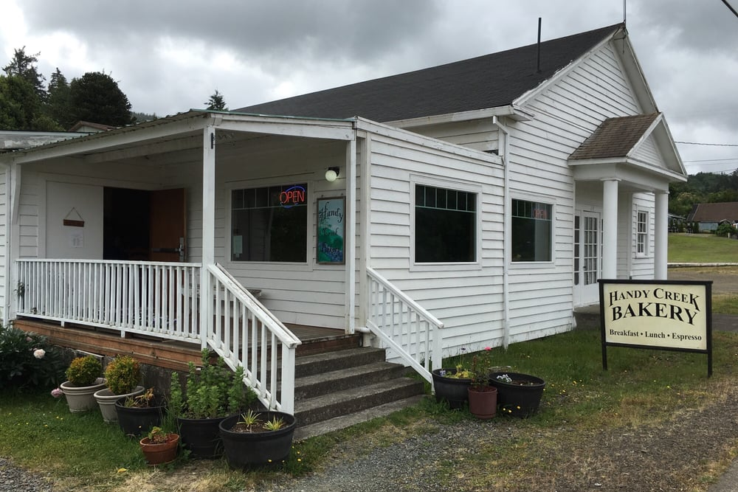
The Handy Creek Bakery features a pitched roof, porch overhang, and painted wood siding. Thus both its materials and overall design are compatible with the design of the proposed project.

Although the structures pictured and discussed above are in the vicinity, there are no “adjoining buildings” on the subject property.

The LUBA and Court of Appeals opinions concluded that the “height and scale” design review standard is not mandatory.

- The application did not demonstrate “how the materials proposed will promote harmony with the structures and site” or “how the materials are compatible with the natural elements.” The application did not identify the “natural elements.” Because the property is “generally pristine in its natural condition,” the City requires greater attention to materials compatibility.

Supplemental Response: The City Council decision identified the site’s “natural elements” to include the river, grassy marsh areas, and tree-covered hills. The proposed building materials have been altered to be more compatible in color and texture with the natural elements, and more in keeping with the expressed preferences of the City representatives who attended the November 1, 2023 meeting. The building will be sided with wood shakes and board-and-batten siding in contrasting wood tones, as shown on the revised plans. The roof will be slate gray or black metal. Several building entrances are covered by canopies in forest green. The window and door trim is black. Those colors harmonize with the water and vegetation. Although there are no adjoining structures on the subject property, we note that the buildings on the Dart parcel and the structure used to house the rail riders business are finished with the same materials: metal roofing and board and batten siding. These nearby structures are discussed in more detail above.

Subsection (2) provides as follows: “Architectural style should not be restricted. Evaluation of a project should be based on quality of design and the relationship to its surroundings. However, the use of styles characteristic of Wheeler and the coastal area are preferred. These include the use of natural wood siding such as cedar shingles. The City encourages the use of pitched roofs, large overhangs, wood fences and wood signs. Colors should be earth tones harmonious with the structure, with bright or brilliant colors used only for accent.”

The City’s Decision found that the application did not meet this guideline. The reasons for noncompliance are listed below, together with the applicant’s responses, application revisions, and supplemental application narrative.

- The application did not sufficiently explain how the building design “incorporates the styles characteristic of Wheeler and the coastal area.” Although the applicant stated that project design was influenced by historical photographs of previous buildings in Wheeler, the application did not include the photographs and did not identify the stylistic elements taken from historic buildings.

Supplemental Response: The building design was influenced by the following historical photographs:

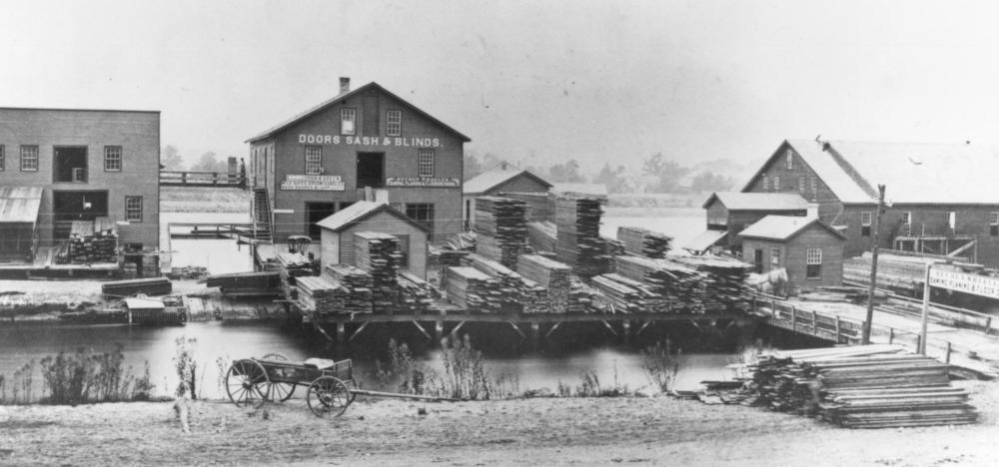

The photograph above shows the former development of the subject property, Wheeler Lumber. The basic layout of the proposed building is reminiscent of the building to the right, while the bay doors and windows of the other buildings in the photograph are replicated in the proposed design. Like most of the buildings in the photograph, the proposed building will be sided with wood.

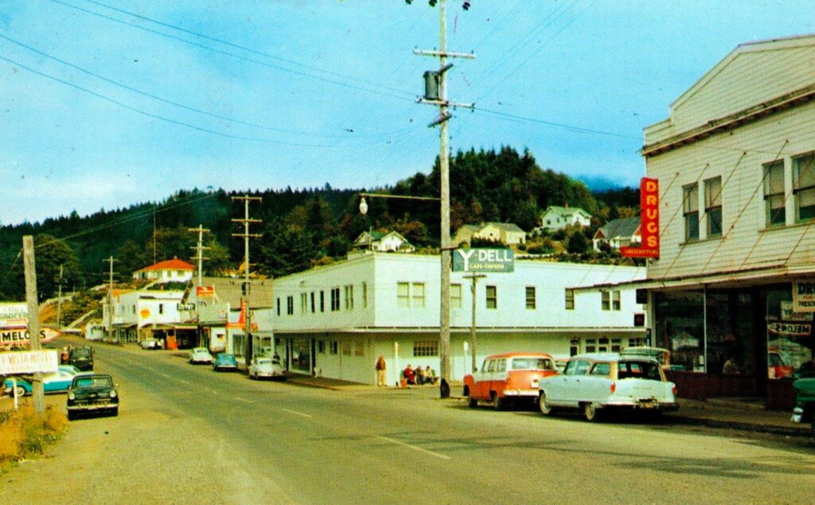

The photograph above shows the buildings along Wheeler’s Main Street (Nehalem Boulevard). The building in the right foreground, as well as the building in the center of the photograph, feature canopies supported by steel struts.

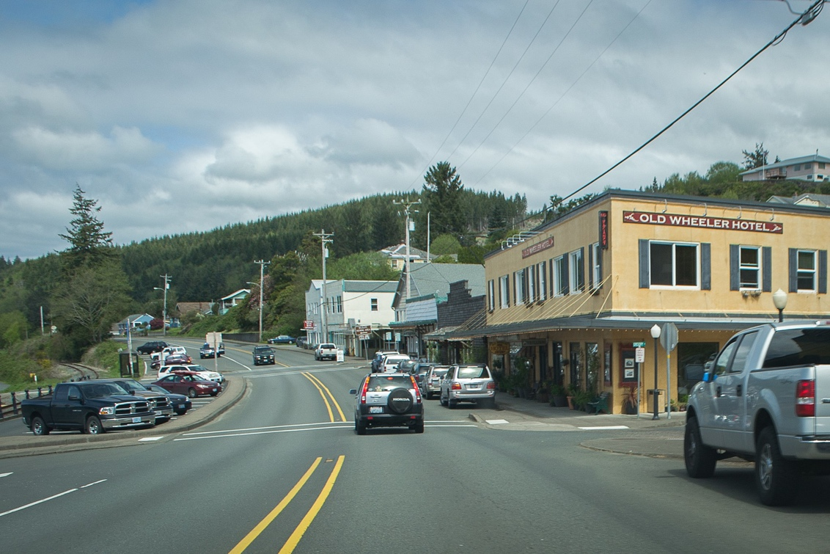

This more recent photograph of the Old Wheeler Hotel also shows canopies supported by struts. This design element has been replicated in the proposed building design, as shown in the site plans.

- The building design does not use the “identified design elements.”

Supplemental Response: The building design uses natural wood siding, including both wood shingles or shakes and board-and-batten style wood. The design also employs pitched roofs, large overhangs (south elevation, east elevation), cedar fencing to screen outdoor storage and HVAC equipment, and a color palette of earth tones, with forest green canopies.

- The application did not provide sufficient information about the “surrounding structures and sites.” The application did not explain how the building design connects to the surrounding area.

Supplemental Response: Detailed information about surrounding structures and sites is provided above in the discussion of WZO Section 11.050.4.b, subsection (1). That discussion is incorporated by reference here.

The building design connects to the surrounding area by preserving its natural shoreline appearance to the maximum extent possible while accommodating development of the use. For example, the building’s finishes are earth tones to match the natural features on the site. The building consolidates a commercial and an industrial use, reducing the structure’s footprint and impact on the natural shoreline.

Subsection (3) provides as follows: “Monotony of design in single or multiple building projects shall be avoided. Variety of detail, form, and site design shall be used to provide visual interest. …”

The City’s Decision found that the application did not meet this guideline. The reasons for noncompliance are listed below, together with the applicant’s responses, application revisions, and supplemental application narrative.

- Only a “relatively small amount of the structure [is] devoted to natural wood.”

Supplemental Response: As shown on the revised site plans, the applicant has redesigned the building to use only natural wood siding.

- The use of two materials for siding (metal and wood) lacks variety and fails to provide visual interest.

Supplemental Response: As shown on the revised site plans, the applicant has redesigned the building to use wood instead of metal siding. The applicant has added canopies, in forest green, over the primary and secondary entrances on the west and north elevations. The canopies have been designed to add visual interest, as well as to replicate an element found in historical Wheeler architecture (see photographs and discussion above). The landscaping around the building, including the addition of “pedestrian amenities” on the south and west sides of the building, also provides visual interest.

- The building’s north and west elevations are “particularly monotonous and lack detail” because they have similar patterns of “windows amidst gray/black metal siding and a single door.”

Supplemental Response: The City’s decision specified that each elevation must be evaluated independently under the “avoid monotony” standard. The City concluded that the building’s south elevation satisfied the standard.

North Elevation: As shown on the revised site plans, the applicant has redesigned the building so that the main industrial loading entrance is located on the north elevation. To make the north side more architecturally appealing, the applicant has added wood siding and a large canopy over the main entrance. In addition, the bay doors will have windows, to add visual interest. A break in the roofline will also be visible on the north elevation.

West Elevation: On the west elevation (which is not visible from Highway 101), the applicant has added wood siding and a matching canopy over the secondary entrance. Proposed landscaping, “pedestrian amenities,” and revegetation of the riparian area will add detail and visual interest to the west elevation, together with a variation in the roof line at the building’s northwest corner.

East Elevation: On the east elevation, which faces toward Highway 101, the building has been redesigned to recreate a mirror image of the same architecture as the south elevation. Wood siding, including wood shakes on the gable and lower half of the building (the industrial building comprises a single story) and board-and-batten siding on the upper half, in a contrasting wood tone, will make the highway-facing elevation more interesting, to satisfy the “avoid monotony” standard.

The LUBA and Court of Appeals opinions rejected the City’s “25% change rule” from its August 16, 2022 decision.

- The applicant submitted inconsistent information about the color of window trim.

Supplemental Response: As shown on the updated site plans submitted in the original application, and as shown again in the revised site plans, the window and door trim is black.

Subsection (4) addresses noise impacts from facilities with late entertainment.

The City’s Decision found that this guideline was not applicable.

Subsection (5) provides as follows: “The impact that structures will have on views from adjacent or other areas will be taken into account.”

The City’s Decision found that the application did not meet this guideline. The reasons for noncompliance are listed below, together with the applicant’s responses, application revisions, and supplemental application narrative.

- The proposed development will “block views” from adjacent structures or structures in other areas, including the residence at 175 Nehalem Boulevard. Compliance with the Zones’ maximum height restriction is not sufficient to comply with this requirement.

Supplemental Response: Because the property is currently vacant, any development will have an effect on views. While such effect must be “taken into account,” this provision may not be used to prevent all development, as LUBA and the Court of Appeals concluded. As discussed in the November 1, 2023 meeting, the applicant’s revisions to the design create variations in the roof line, which will make the view more aesthetically appealing.

The building and site design mitigate the impact on views to the maximum extent possible while accommodating development of the use. For example, the building’s finishes are earth tones to match the natural features on the site. The building consolidates a commercial and an industrial use, reducing the structure’s footprint and impact on the natural shoreline.

Subsection (6) addresses store front requirements.

The City’s Decision found that the application met this guideline.

Subsection (7) addresses minimum window requirements.

The City’s Decision found that the application met this guideline.

Subsection (8) addresses minimum landscaping requirements.

The City’s Decision found that the application met this guideline.

Subsection (9) addresses architectural features to separate ground floors from upper stories.

The City’s Decision found that the application met this guideline.

Subsection (10) addresses lighting and “articulated facades” requirements.

The City’s Decision found that the application met this guideline.

Subsection (11) addresses pedestrian weather protection.

The City’s Decision found that the application met this guideline.

WZO Section 11.111 establishes standards for shoreland development.

Section 11.111.1 establishes setback requirements.

The City’s Decision found that the application met this requirement.

Section 11.111.2 establishes setbacks for riparian vegetation protection.

The City’s Decision found that the application met this requirement, to the extent the requirement is applicable.

Section 11.111.3 establishes waterfront access requirements.

The City’s Decision found that the application met this requirement.

Section 11.111.4 establishes signage requirements.

The City’s Decision found that the application will meet this requirement through a separate sign permit.

Section 11.111.5 establishes lot size requirements.

The City’s Decision found that this requirement was not applicable.

Section 11.111.6 establishes requirements for the installation of utilities.

The City’s Decision found that the application met this requirement.

Section 11.111.7 establishes parking restrictions.

The City’s Decision found that the application complied with these restrictions.

Section 11.111.8 requires design review under WZO Section 11.050.

The City’s Decision applied design review standards.

Section 11.111.9 addresses erosion control and flood control.

The City’s Decision found that the application satisfied this provision and added that an NPDES 1200-C permit from DEQ is required before construction.

Supplemental Response: The applicant provided the City with a copy of the NPDES 1200-C permit from DEQ on October 30, 2023.

